F LYWOO MR.Croc-HD FPV Freestyle Drone PNP/BNF MANUAL
Instructions:
- Default UARTS port Settings
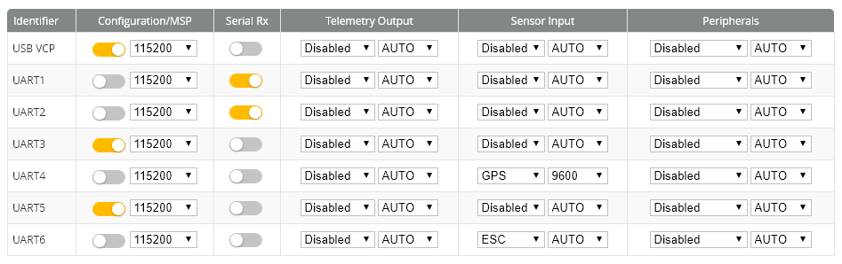
2. Setting motor direction, connect usb, use BLHeliSuite software to set direction and calibrates the throttle.
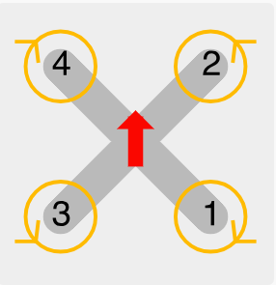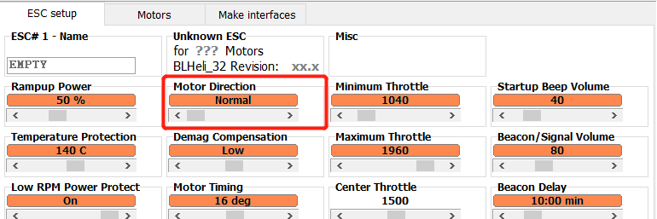
3. Wiring diagram

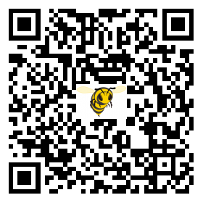
Betaflight APP
WWW.FLYWOO.NET
Warning : that the propeller must be removed to connect the computer Settings

